Music development plan summary:
Edenbridge Primary School

Overview
Detail | Information
Academic year that this summary covers | 2025-26
Date this summary was published | Autumn 2025
Date this summary will be reviewed | Autumn 2026
Name of the school music lead | Helen Byard
Name of school leadership team member with responsibility for music (if different)
Name of local music hub | Kent and Medway Music  Lead School for Primary Music
Name of other music education organisation(s)  (if partnership in place) | Music Mark(Ambition and Quality) 2025

Part A: Curriculum music
This is a summary of how our school delivers music education to all our pupils across three areas – curriculum music, co-curricular provision and musical experiences – and what changes we are planning in future years.
The Music Curriculum at Edenbridge Primary School
At Edenbridge, we teach a bespoke, progressive music curriculum. Each term has a strong focus on a particular musical element and combines listening, composing and performing skills also referred to as the 3 pillars of progression in music education: technical, constructive and expressive. The music curriculum is guided by the National Curriculum for Music, Model Music Curriculum, International Primary Curriculum and the National Plan for Music Education (2022). Each class has a one hour lesson taught by Mrs H Byard, a music specialist teacher. Every child, from Reception to Year 6, receives a one hour music lesson every week in a dedicated, well-resourced music room.
We are a Music Mark (Ambition and Quality) school – We have been awarded Music Mark status for the last 5 years.

7 features of high-quality music provision:

- timetabled curriculum music of at least one hour each week of the school year for key stages 1 to 3 - Currently in place
- access to lessons across a range of instruments, and voice – Currently in place
- a school choir or vocal ensemble – Currently in place
- a school ensemble, band or group – Currently in place
- space for rehearsals and individual practice – Currently in place
- a termly school performance – Currently in place
- opportunity to enjoy live performance at least once a year – Currently in place

Singing
Singing is embedded into the whole school curriculum and is included in every music lesson. We have weekly singing assemblies for KS1 and KS2 that include a cultural diverse repertoire and have strong PSHE links. Children have the opportunity to sing every week, inside and outside of music lessons.
Music Curriculum – Example of Year 1 Overview:
MUSIC OVERVIEW – Year 1
 | Week 1 | Week 2 | Week 3 |  | Week 4 |  | Week 5 |  | Week 6
Term 1  Pulse | To understand the word "pulse" and demonstrate understanding using clapping technique | To be able to respond to music using body parts. | To be able to play or sing long and short sounds |  | To be able to follow a pulse and perform simple rhythms |  | To be able to create long and short sounds |  | To create and perform using instruments to keep the pulse and play the rhythm
Term 2  Rhythm  Extra-curricular  Christmas concert | To understand the difference between rhythm and pulse | To maintain a pulse whilst performing a rhythm as a group | To understand and perform movements to indicate rest |  | To be able to copy a rhythm and play it back |  | To perform rhythms at different tempos |  | To play along with the rhythm of song
Term 2  IPC Topic  ‘Treasure Island’ | Music Task 1-Sea Shanties  Music Task 2 – Pirates Journey (Compose)  Music Task 3 – Pirates Journey (Perform)
Term 3  Technology, structure and form | To explore and change sounds and music through play and technology | To use technology to create and change sounds | To further develop our knowledge on editing sounds using technology |  | To edit the song 'Down in the Jungle' |  | To use technology to add sound effect to a story |  | To perform the story with our very own sounds
Term 4  Voice and Instrument  Extra-curricular  End of Year concert | To understand the importance of a vocal warm up | To learn to recognise and repeat higher and lower sounds | To understand and recognise basic graphic notation |  | To explore "pause" and further graphic notation |  | To recap pitch and explore dynamics & melody |  | To perform songs with a range of notes
Term 5 IPC Topic  ‘A Day in a Life’ | Music Task 1 – Create a Soundscape. Using tuned and untuned/voice. ‘The Town’ theme.  Music Task 2 – Chants. ‘Jobs’ theme.  Music Task 3 – Create opening music for their show. Lyrics and catchy tune
Term 5  Pitch | To recap what pitch is and how we recognise different levels of pitch | To learn to identify high and low pitch sounds |  | To sing notes of different pitches |  | To understand and create Glissandos |  | To recognise and control changes in pitch vocally and when playing instruments |  | To compose music combining rhythm, pitch, dynamics, timbre & tempo

Music in EYFS
Musical Development Matters in the Early Years (Aspects of musical learning and development):
Birth to Five (Expressive Arts and Design)

- Hearing and Listening
- Vocalising and Singing
- Moving and Dancing
- Exploring and Playing

‘These four main aspects of music thread through all areas of learning and development. Music can be a way of exploring, communicating and responding to experience and making music with others can be a valuable social experience. This interaction with others, whether this be with one other person or a group, is personal to each individual and is often an expression of feelings. All vocal communication is comprised of musical elements such as pitch, rhythm and timbre, demonstrating that musicality is an intrinsic part of being human. Music should be seen as a core component of children’s learning and should be shared with young children to ensure they have broad, balanced and rounded experiences in early childhood and beyond.’

Main aims of the EYFS music curriculum:  - To have fun and enjoy making music  - To develop musical skills and knowledge  - To encourage creativity and self-expression  - To introduce a wide range of new vocabulary  - To aid social and emotional development  - To support learning in other areas of the curriculum | Singing and playing instruments encourage:  - Finger-play to develop fine motor skills  - Concept of number / Use phonics skills  - Spatial awareness  - Control of whole-body movements  - Hand-eye coordination  - Turn-takings / Sharing / Working together  - Listening skills  - Communication skills | Musical terms introduced:  - Pulse: like a heartbeat, a steady beat underlying the music  - Rhythm: pattern of sound  - Pitch: high sounds, low sounds  - Structure: how a piece of music/song is built up  - Dynamics: loud, quiet, getting louder, getting quieter  - Timbre: the character of a sound, e.g., smooth sound, spikey sound, scratchy sound  - Texture: layers in the music, e.g., one sound or several sounds  - Tempo: speed  - Melodic shape: this is the ‘outline’ of the song or piece of music  - Genre: the type of music, e.g., pop, jazz, folk, classical

SEND Music Provision
Teaching and Learning:
- Makaton (musical elements and instructions)
- Encouragement to use their voices expressively and to use different forms of communication − such as gesture − to compensate for difficulties when singing and speaking.
- Opportunities to learn about music through physical contact with an instrument and/or sound source where they are unable to hear sounds clearly or at all.
- Demonstrate co-ordination of instrument skills clearly.
- Respond to pupils’ diverse learning needs.
- Modify the curriculum to remove barriers so all pupils meet the same objectives.
- Language is clear, unambiguous, and accessible.
- Key words, meanings and symbols are highlighted, explained, and written up, or available in an alternative other way.
- Visual clues available − such as the use of symbols − by using larger print, colour codes, multi-sensory reinforcement, and a greater emphasis on aural memory skills.
- Questions are prepared in different styles/levels for different pupils − careful preparation ensures all pupils have opportunities to answer open-ended questions.
- Pupils with communication impairments are given ‘ time to think’ about questions before being required to respond.
Grouping pupils:
- All forms of pupil grouping include pupils with SEN and/or disabilities.
- Manageable mixed ability grouping or pairing is the norm, except when carefully planned for a particular purpose.
- Sequence of groupings is outlined for pupils.
- The transition from whole class to group or independent work, and back, is clearly signalled. This is particularly helpful for pupils on the autistic spectrum.
Sound and light issues:
- Provide ear defenders when necessary.
- Background noise and reverberation are reduced.
- Glare is reduced.
- Pupils use hearing and low vision aids, where necessary.
- Video presentations have subtitles for deaf or hearing-impaired pupils and those with communication difficulties, where required.
Resources:
- Clearly labelled.
- Easy to reach / handle.
- Inclusive for all.
- Access to adapted instruments or ICT to overcome difficulties with mobility or manipulative skills.

Part B: Co-curricular music
Co-Curricular Music Opportunities at Edenbridge Primary School
Music Tuition – We have a wide range of co-curricular music available to our pupils including: piano, vocal, strings (violin/guitar), brass (trumpet) woodwind (saxophone, clarinet, recorder) drums, Rock Steady, orchestra, KS2 Choir, KS1 Musical Theatre club.
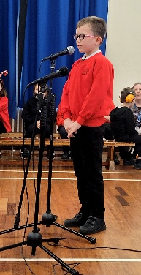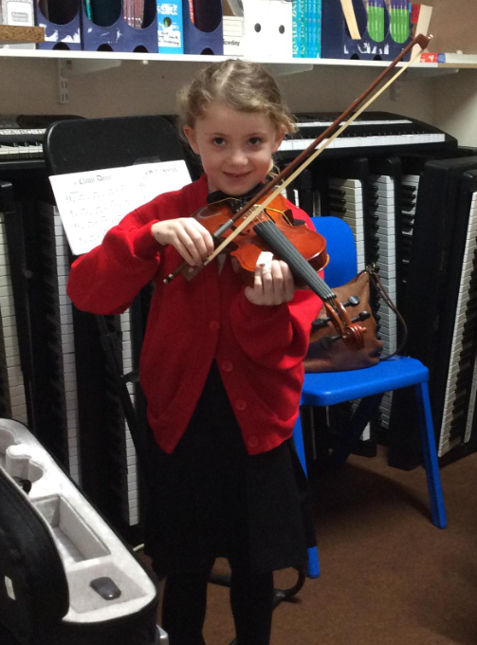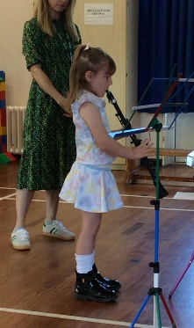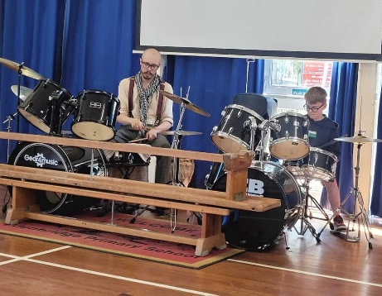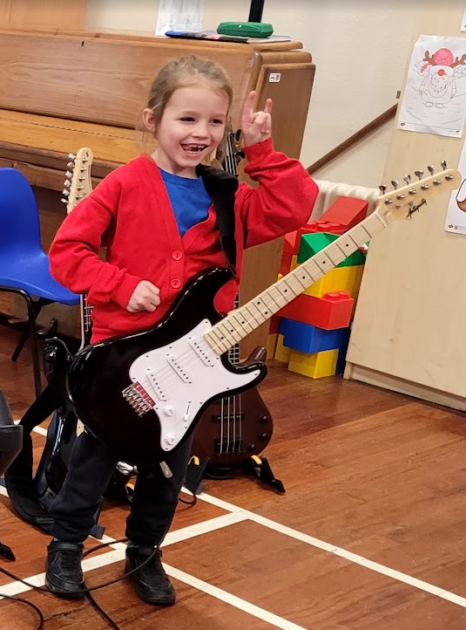
 | Piano | Vocals | Percussion  (drums) | Strings (violin/cello) | Strings  (guitar) | Brass (trumpet) | Woodwind (clarinet/ flute  Recorder/sax) | Ensemble | Ukulele | Choir  KS2 | Rock Steady
Year 2 |  |  |  |  |  |  | 3 | 3 |  |  | 7
Year 3 | 1 |  | 1 |  | 1 |  | 1 | 1 |  |  | 8
Year 4 | 4 | 1 | 1 | 1 |  |  | 1 | 1 |  |  | 5
Year 5 | 2 | 4 | 5 | 2 |  |  | 2 | 2 |  |  | 4
Year 6 |  |  | 2 | 2 |  |  |  |  | 55
Total | 7 | 5 | 9 | 5 | 1 |  | 7 | 7 | 55 | 35 | 24
Total of 155 pupils taking part in co-curricular music lessons (Sept’25)
Music Lessons – 1:1 / Small group

Piano – We Teach Music – admin@weteachmusic.co.uk
Guitar – Kent Music Hub – www.kent-music.com/music-lessons
Strings - Kent Music Hub – www.kent-music.com/music-lessons
Brass and Woodwind – Music For Schools Foundation – www.mfsf.org
Drumming – Samuel GR Morgan – samgrmorgan@gmail.com
Vocal Coaching – Jane Ryall – janeryalluk.yahoo.co.uk
Rock Band - Rock Steady Music School – www.rocksteadymusicschool.com

Associations / Collaborations
Kent and Medway Music Hub/ We Teach Music / Music for All Foundation/ Rock Steady / Young Voices / Music Mark / ISM / MTA Ensemble magazine / Music Education Solutions Primary Music Magazine.

Financial assistance for any 1:1 music lessons (can be awarded up to 75% of payment and does not have to be a lessons with
tutor from Kent Music) Apply here: https://www.kent-music.com/financial-assistance/

Part C: Musical experiences
This is about all the other musical events and opportunities that we organise, such as singing in assembly, concerts and shows, and trips to professional concerts.
Music Events and Concerts
We arrange a number of activities that take place off the school site and out of school hours, which support the aim of providing opportunities that enrich the curriculum, enabling the children to have first-hand experience of a wide range of musical activities. Such activities and workshops include the Sevenoaks Singing Festival, Young Voices at The O2 Arena, London, Djembe drumming workshops, School of Noise, Kidenza, School of Beatbox, Beat Goes On, Edenbridge Got Talent, Year 6 performance, end of term instrumental concerts, performing at the local care home and live music from a range of professional musicians. We have links to the local music community through Edenbridge Brass Band, St. Peter and Pauls Church and the Edenbridge Arts Trust.

In the future:
Areas for development 2025/26:
- Encourage more live music performances, both from our pupils and outside musicians.
- Continue to develop music in EYFS.
- Collaboration projects with local Secondary schools to support Yr.6 / Yr.7 transition.
- Inclusion and SEND awareness in music. Regular review and adaption of lesson planning for accessibility.
- Start a KS1 choir.
- Maintain strong partnership with Kent and Medway Music Hub.

Further information (optional)
Kent and Medway Music Hub
https://www.kent-music.com/
The Department for Education publishes a guide for parents and young people on how they can get involved in music in and out of school, and where they can go to for support beyond the school.
Music education: information for parents and young people - GOV.UK (www.gov.uk)
National Curriculum for Music (Primary)
https://www.gov.uk/government/publications/national-curriculum-in-england-music-programmes-of-study
National Plan for Music Education (2022)
The power of music to change lives: a national plan for music education - GOV.UK (www.gov.uk)
Model Music Curriculum
Model_Music_Curriculum_Key_Stage_1__2_FINAL.pdf (publishing.service.gov.uk)

