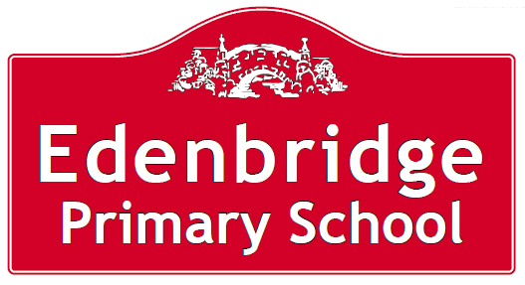 



**Free School Meals and Pupil Premium**

# If you are in receipt of one of the family income and benefits listed overleaf then your child might be eligible for free

# school meals. Healthy school food has obvious health benefits and registering for free meals could also raise extra funds from the government and provide valuable support like extra tuition, additional teaching staff or after school activities.

To check if your child is eligible, we need information about you and your child.

|  |  |  |  |
| --- | --- | --- | --- |
| Child’s Last Name | Child’s First Name | Childs Date of Birth | Name of School |
| Click or tap here to enter text. | Click or tap here to enter text. | Click or tap to enter a date. | Click or tap here to enter text. |
| Click or tap here to enter text. | Click or tap here to enter text. | Click or tap to enter a date. | Click or tap here to enter text. |

**PARENT/GUARDIAN DETAILS**

|  |  |  |
| --- | --- | --- |
|  | Parent/Guardian 1 | Parent/Guardian 2 |
| Last name | Click or tap here to enter text. | Click or tap here to enter text. |
| First Name | Click or tap here to enter text. | Click or tap here to enter text. |
| Date of Birth | Click or tap to enter a date. | Click or tap to enter a date. |
| National Insurance Number* | Click or tap here to enter text. | Click or tap here to enter text. |
| National Asylum Support Service (NASS) Number* | Click or tap here to enter text. | Click or tap here to enter text. |
| Daytime Telephone Number | Click or tap here to enter text. | Click or tap here to enter text. |
| Mobile Number | Click or tap here to enter text. | Click or tap here to enter text. |
| Address including postcode | Click or tap here to enter text. | Click or tap here to enter text. |

**FAMILY INCOME AND BENEFIT DETAILS**

If you receive any of the benefits listed below, please place an X in this box.

* Income Support
* Income-based Jobseekers Allowance
* Income-related Employment and Support Allowance
* Support from NASS under part 6 of the Immigration and Asylum Act 1999
* the guarantee element of Pension Credit
* Child Tax Credit (with no Working Tax Credit)
* Working Tax Credit run-on
* Universal Credit.

**Universal Credit**

If you are in receipt of **Universal Credit**, is your net earned family income over £7,400 per year? (Please place an X in the appropriate box).

Your net earned income is your household income after taxes and deductions. It does **not** include income through Universal Credit or other benefits that you may receive.

Yes  No  Unsure

**Child Tax Credit**

If you are in receipt of **Child Tax Credit,** is your joint gross annual income over £16,190 per year? (Please place an X in the appropriate box).

Your joint gross income is your household income before taxes are taken into account.

Yes  No  Unsure

If you’re not sure whether you receive one of the listed benefits, or what your household income is, but you would still like us to check whether your child is eligible for free school meals, please place an X in this box.

**DECLARATION**

The information I have given on this form is complete and accurate. I understand that my personal information is held securely and will be used only for local authority purposes. I agree to the local authority using this information to process my application for free school meals. I also agree to notify the local authority in writing of any change in my family’s financial circumstances as set out in this form.

Signature of parent/guardian: Click or tap here to enter text. Date: Click or tap to enter a date.

**Thank you for completing this form and helping to make sure your child’s school is as well funded as possible.**

**How the information in this form will be used**

The information you provide in this form will be used by the council to confirm receipt of one of the listed welfare benefits. Once this is confirmed, this helps to decide how much money your child’s school will receive each year.

The information will also be used in relation to pupils in year 3 or above to decide whether they are eligible for free school meals.

You only need to complete this form once and it will last for the duration of your child’s time at their current school. You should contact the school or local authority if you have a change in financial circumstances.

We are committed to ensuring that the personal and sensitive information that we hold about you is protected and kept safe and secure, and we have measures in place to prevent the loss, misuse or alteration of your personal information. We will use the information you provide to assess entitlement to free school meals. The information may also be shared with other Council departments to offer benefits and services.